Peer Evaluation for Lab 5 – Chapter 20
Your name: (Your lab is the one being evaluated) | John Bell
Name(s) of peer evaluator(s) | self
Date: | 05/18/17

Instructions
You should have already completed Lab 5. After you and a peer have evaluated your work, you will submit this evaluation along with screen shots and source code indicated in moodle. You may make corrections to your work as a result of the evaluation.
In Class Exercises – 20-1
Completed Exercise?  - Customer Maintenance application that allows you to search for customers, add a customer, modify a customer and delete a customer?  - MMABooksDB class has been created? Contains the method GetConnection?  - CustomerDB class has been created? Contains GetCustomer, UpdateCustomer, AddCustomer and DeleteCustomer methods?  - StateDB class has been created? Contains GetStates method?  - Errors are handled appropriately? What kinds of errors are handled and how?  - Screen shot of application running is included?  - Source code includes 3 DB classes? | y

Screen Shots and Source Code
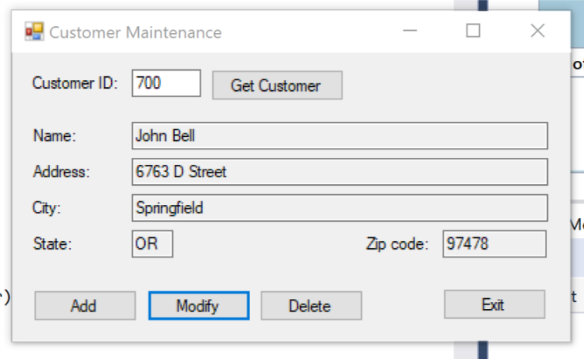
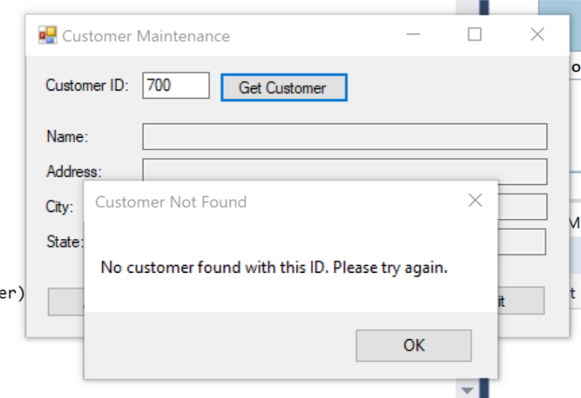
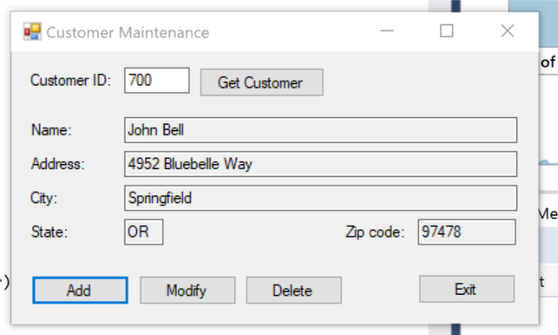

CUSTOMERDB CLASS
using System;
using System.Collections.Generic;
using System.Linq;
using System.Text;
using System.Threading.Tasks;
using System.Data.SqlClient;
using System.Data;

namespace CustomerMaintenance
{
public static class CustomerDB
{
public static Customer GetCustomer(int customerID)
{
SqlConnection connection = MMABooksDB.GetConnection();
string selectStatement
= "SELECT CustomerID, Name, Address, City, "
+ "State, ZipCode "
+ "FROM Customers "
+ "WHERE CustomerID = @CustomerID";
SqlCommand selectCommand =
new SqlCommand(selectStatement, connection);
selectCommand.Parameters.AddWithValue(
"@CustomerID", customerID);
try
{
connection.Open();
SqlDataReader custReader =
selectCommand.ExecuteReader(
CommandBehavior.SingleRow);

if (custReader.Read())
{
Customer customer = new Customer();
customer.CustomerID = (int)custReader["CustomerID"];
customer.Name = custReader["Name"].ToString();
customer.Address = custReader["Address"].ToString();
customer.City = custReader["City"].ToString();
customer.State = custReader["State"].ToString();
customer.ZipCode = custReader["ZipCode"].ToString();
return customer;
}
else
{
return null;
}
}
catch (SqlException ex)
{
throw ex;
}
finally
{
connection.Close();
}
}
public static int AddCustomer(Customer customer)
{
SqlConnection connection = MMABooksDB.GetConnection();
string insertStatement =
"INSERT Customers " +
"(Name, Address, City, State, ZipCode) " +
"VALUES (@Name, @Address, @City, @State, @ZipCode)";
SqlCommand insertCommand =
new SqlCommand(insertStatement, connection);
insertCommand.Parameters.AddWithValue(
"@Name", customer.Name);
insertCommand.Parameters.AddWithValue(
"@Address", customer.Address);

insertCommand.Parameters.AddWithValue(
"@City", customer.City);
insertCommand.Parameters.AddWithValue(
"@State", customer.State);
insertCommand.Parameters.AddWithValue(
"@ZipCode", customer.ZipCode);
try
{
connection.Open();
insertCommand.ExecuteNonQuery();
string selectStatement =
"SELECT IDENT_CURRENT('Customers') FROM Customers";
SqlCommand selectCommand =
new SqlCommand(selectStatement, connection);
int customerID = Convert.ToInt32(
selectCommand.ExecuteScalar());
return customerID;
}
catch (SqlException ex)
{
throw ex;
}

finally
{
connection.Close();
}
}
public static bool UpdateCustomer(Customer oldCustomer,
Customer newCustomer)
{
SqlConnection connection = MMABooksDB.GetConnection();
string updateStatement =
"UPDATE Customers SET " +
"Name = @NewName, " +
"Address = @NewAddress, " +
"City = @NewCity, " +
"State = @NewState, " +
"ZipCode = @NewZipCode " +
"WHERE Name = @OldName " +
"AND Address = @OldAddress " +
"AND City = @OldCity " +
"AND State = @OldState " +
"AND ZipCode = @OldZipCode";

SqlCommand updateCommand =
new SqlCommand(updateStatement, connection);
updateCommand.Parameters.AddWithValue(
"@NewName", newCustomer.Name);
updateCommand.Parameters.AddWithValue(
"@NewAddress", newCustomer.Address);
updateCommand.Parameters.AddWithValue(
"@NewCity", newCustomer.City);
updateCommand.Parameters.AddWithValue(
"@NewState", newCustomer.State);
updateCommand.Parameters.AddWithValue(
"@NewZipCode", newCustomer.ZipCode);
updateCommand.Parameters.AddWithValue(
"@OldName", oldCustomer.Name);
updateCommand.Parameters.AddWithValue(
"@OldAddress", oldCustomer.Address);
updateCommand.Parameters.AddWithValue(
"@OldCity", oldCustomer.City);
updateCommand.Parameters.AddWithValue(
"@OldState", oldCustomer.State);
updateCommand.Parameters.AddWithValue(
"@OldZipCode", oldCustomer.ZipCode);

try
{
connection.Open();
int count = updateCommand.ExecuteNonQuery();
if (count > 0)
return true;
else
return false;
}
catch (SqlException ex)
{
throw ex;
}
finally
{
connection.Close();
}
}

public static bool DeleteCustomer(Customer customer)
{
SqlConnection connection = MMABooksDB.GetConnection();
string deleteStatement =
"DELETE FROM Customers " +
"WHERE Name = @Name " +
"AND Address = @Address " +
"AND City = @City " +
"AND State = @State " +
"AND ZipCode = @ZipCode";
SqlCommand deleteCommand =
new SqlCommand(deleteStatement, connection);
deleteCommand.Parameters.AddWithValue(
"@Name", customer.Name);
deleteCommand.Parameters.AddWithValue(
"@Address", customer.Address);
deleteCommand.Parameters.AddWithValue(
"@City", customer.City);
deleteCommand.Parameters.AddWithValue(
"@State", customer.State);
deleteCommand.Parameters.AddWithValue(
"@ZipCode", customer.ZipCode);

try
{
connection.Open();
int count = deleteCommand.ExecuteNonQuery();
if (count > 0)
return true;
else
return false;
}
catch (SqlException ex)
{
throw ex;
}
finally
{
connection.Close();
}
}
}

}

STATEDB CLASS

using System;
using System.Collections.Generic;
using System.Linq;
using System.Text;
using System.Threading.Tasks;
using System.Data.SqlClient;

namespace CustomerMaintenance
{
public static class StateDB
{

public static List<State> GetStates()
{
List<State> states = new List<State>();
SqlConnection connection = MMABooksDB.GetConnection();

string selectStatement = "SELECT StateCode, StateName "
+ "FROM States "
+ "ORDER BY StateName";

SqlCommand selectCommand = new SqlCommand(selectStatement, connection);

try
{
connection.Open();
SqlDataReader reader = selectCommand.ExecuteReader();
while (reader.Read())
{
State s = new State();
s.StateCode = reader["StateCode"].ToString();
s.StateName = reader["StateName"].ToString();
states.Add(s);
}
reader.Close();
}
catch (SqlException ex)
{
throw ex;
}
finally
{
connection.Close();
}
return states;
}
}
}

MMABOOKDB CLASS

using System;
using System.Collections.Generic;
using System.Linq;
using System.Text;
using System.Threading.Tasks;
using System.Data.SqlClient;

namespace CustomerMaintenance
{
class MMABooksDB
{
public static SqlConnection GetConnection()
{
string connectionString = "Data Source=DESKTOP-THP73QI\\SQLEXPRESS;Initial Catalog=MMABooks;Integrated Security=True";
SqlConnection connection = new SqlConnection(connectionString);
return connection;
}
}
}

MODIFY CUSTOMER FORM

using System;
using System.Collections.Generic;
using System.ComponentModel;
using System.Data;
using System.Drawing;
using System.Linq;
using System.Text;
using System.Threading.Tasks;
using System.Windows.Forms;

namespace CustomerMaintenance
{
public partial class frmAddModifyCustomer : Form
{
public frmAddModifyCustomer()
{
InitializeComponent();
}

public bool addCustomer;
public Customer customer;

private void frmAddModifyCustomer_Load(object sender, EventArgs e)
{
this.LoadStateComboBox();
if (addCustomer)
{
this.Text = "Add Customer";
cboStates.SelectedIndex = -1;
}
else
{
this.Text = "Modify Customer";
this.DisplayCustomer();
}
}

private void LoadStateComboBox()
{
List<State> states = new List<State>();
try
{
states = StateDB.GetStates();
cboStates.DataSource = states;
cboStates.DisplayMember = "StateName";
cboStates.ValueMember = "StateCode";
}
catch (Exception ex)
{
MessageBox.Show(ex.Message, ex.GetType().ToString());
}
}

private void DisplayCustomer()
{
txtName.Text = customer.Name;
txtAddress.Text = customer.Address;
txtCity.Text = customer.City;
cboStates.SelectedValue = customer.State;
txtZipCode.Text = customer.ZipCode;
}

private void btnAccept_Click(object sender, EventArgs e)
{
if (IsValidData())
{
if (addCustomer)
{
customer = new Customer();
this.PutCustomerData(customer);
try
{
customer.CustomerID = CustomerDB.AddCustomer(customer);
this.DialogResult = DialogResult.OK;
}
catch (Exception ex)
{
MessageBox.Show(ex.Message, ex.GetType().ToString());
}
}
else
{
Customer newCustomer = new Customer();
newCustomer.CustomerID = customer.CustomerID;
this.PutCustomerData(newCustomer);
try
{
if (! CustomerDB.UpdateCustomer(customer, newCustomer))
{
MessageBox.Show("Another user has updated or " +
"deleted that customer.", "Database Error");
this.DialogResult = DialogResult.Retry;
}
else
{
customer = newCustomer;
this.DialogResult = DialogResult.OK;
}
}
catch (Exception ex)
{
MessageBox.Show(ex.Message, ex.GetType().ToString());
}
}
}
}

private bool IsValidData()
{
return
Validator.IsPresent(txtName) &&
Validator.IsPresent(txtAddress) &&
Validator.IsPresent(txtCity) &&
Validator.IsPresent(cboStates) &&
Validator.IsPresent(txtZipCode);
}

private void PutCustomerData(Customer customer)
{
customer.Name = txtName.Text;
customer.Address = txtAddress.Text;
customer.City = txtCity.Text;
customer.State = cboStates.SelectedValue.ToString();
customer.ZipCode = txtZipCode.Text;
}
}
}

CUSTOMER MAINTENANCE FORM

using System;
using System.Collections.Generic;
using System.ComponentModel;
using System.Data;
using System.Drawing;
using System.Linq;
using System.Text;
using System.Threading.Tasks;
using System.Windows.Forms;
using System.Data.SqlClient;

namespace CustomerMaintenance
{
public partial class frmCustomerMaintenance : Form
{
public frmCustomerMaintenance()
{
InitializeComponent();
}

private Customer customer;

private void btnGetCustomer_Click(object sender, EventArgs e)
{
if (Validator.IsPresent(txtCustomerID) &&
Validator.IsInt32(txtCustomerID))
{
int customerID = Convert.ToInt32(txtCustomerID.Text);
this.GetCustomer(customerID);
if (customer == null)
{
MessageBox.Show("No customer found with this ID. " +
"Please try again.", "Customer Not Found");
this.ClearControls();
}
else
this.DisplayCustomer();
}
}

private void GetCustomer(int customerID)
{
try
{
customer = CustomerDB.GetCustomer(customerID);
}
catch (Exception ex)
{
MessageBox.Show(ex.Message, ex.GetType().ToString());
}
}

private void ClearControls()
{
txtCustomerID.Text = "";
txtName.Text = "";
txtAddress.Text = "";
txtCity.Text = "";
txtState.Text = "";
txtZipCode.Text = "";
btnModify.Enabled = false;
btnDelete.Enabled = false;
txtCustomerID.Select();
}

private void DisplayCustomer()
{
txtName.Text = customer.Name;
txtAddress.Text = customer.Address;
txtCity.Text = customer.City;
txtState.Text = customer.State;
txtZipCode.Text = customer.ZipCode;
btnModify.Enabled = true;
btnDelete.Enabled = true;
}

private void btnAdd_Click(object sender, EventArgs e)
{
frmAddModifyCustomer addCustomerForm = new frmAddModifyCustomer();
addCustomerForm.addCustomer = true;
DialogResult result = addCustomerForm.ShowDialog();
if (result == DialogResult.OK)
{
customer = addCustomerForm.customer;
txtCustomerID.Text = customer.CustomerID.ToString();
this.DisplayCustomer();
}
}

private void btnModify_Click(object sender, EventArgs e)
{
frmAddModifyCustomer modifyCustomerForm = new frmAddModifyCustomer();
modifyCustomerForm.addCustomer = false;
modifyCustomerForm.customer = customer;
DialogResult result = modifyCustomerForm.ShowDialog();
if (result == DialogResult.OK)
{
customer = modifyCustomerForm.customer;
this.DisplayCustomer();
}
else if (result == DialogResult.Retry)
{
this.GetCustomer(customer.CustomerID);
if (customer != null)
this.DisplayCustomer();
else
this.ClearControls();
}
}

private void btnDelete_Click(object sender, EventArgs e)
{
DialogResult result = MessageBox.Show("Delete " + customer.Name + "?",
"Confirm Delete", MessageBoxButtons.YesNo, MessageBoxIcon.Question);
if (result == DialogResult.Yes)
{
try
{
if (!CustomerDB.DeleteCustomer(customer))
{
MessageBox.Show("Another user has updated or deleted " +
"that customer.", "Database Error");
this.GetCustomer(customer.CustomerID);
if (customer != null)
this.DisplayCustomer();
else
this.ClearControls();
}
else
this.ClearControls();
}
catch (Exception ex)
{
MessageBox.Show(ex.Message, ex.GetType().ToString());
}
}
}

private void btnExit_Click(object sender, EventArgs e)
{
this.Close();
}
}
}

